

**Faculty of Information Science and Technology (FIST)**

**TCC3141 Cloud Computing - Project Report**

**Trimester 4 2022/2023**

|  |  |  |  |
| --- | --- | --- | --- |
| **No.** | **Student Name** | **Student ID** | **Email** |
| **1.** | Choo Rong Xian | 1191100289 | 1191100289@student.mmu.edu.my |
| **2.** | Tey Hua Chian | 1191200984 | 1191200984@student.mmu.edu.my |
| **3.** | Sammi Tan Hui Qin | 1191201697 | 1191201697@student.mmu.edu.my |
| **4.** | Priscilla Wong Hong Hui | 1191200517 | 1191200517@student.mmu.edu.my |

Table of Contents

Introduction 3

Network Layout 4

Implementation 5

**Phase 1** 5

**Phase 2** 14

**Phase 3** 20

**Phase 4** 23

Conclusion 25

# Introduction

The goal of this project is to design and develop an inventory management system with the available Amazon services. We were provided with high-level instructions and lab training. We develop the system with the AWS Academy Learner Lab created by our lab instructor, and we have been provided with 100$ to utilise the available resources at minimum cost. We constructed a basic web application named LALAGIFT using a single Amazon Elastic Compute Cloud (Amazon EC2) instance and Amazon Relational Database Service (Amazon RDS) as the database. We also utilised Elastic Load Balancer (ELB) to create decoupled architecture and Auto Scaling service to make our system architecture scalable.

# Network Layout

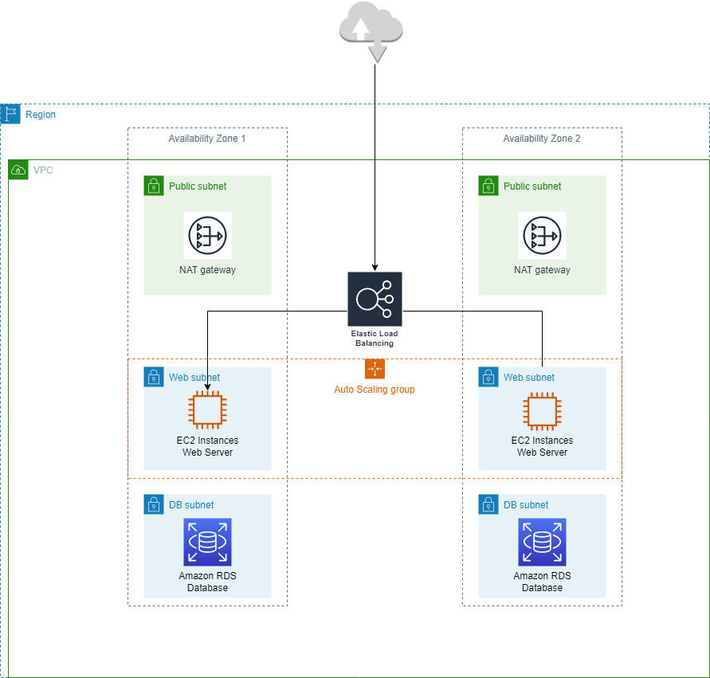

Figure 1 AWS Network Diagram

# Implementation

## **Phase 1**

**Website**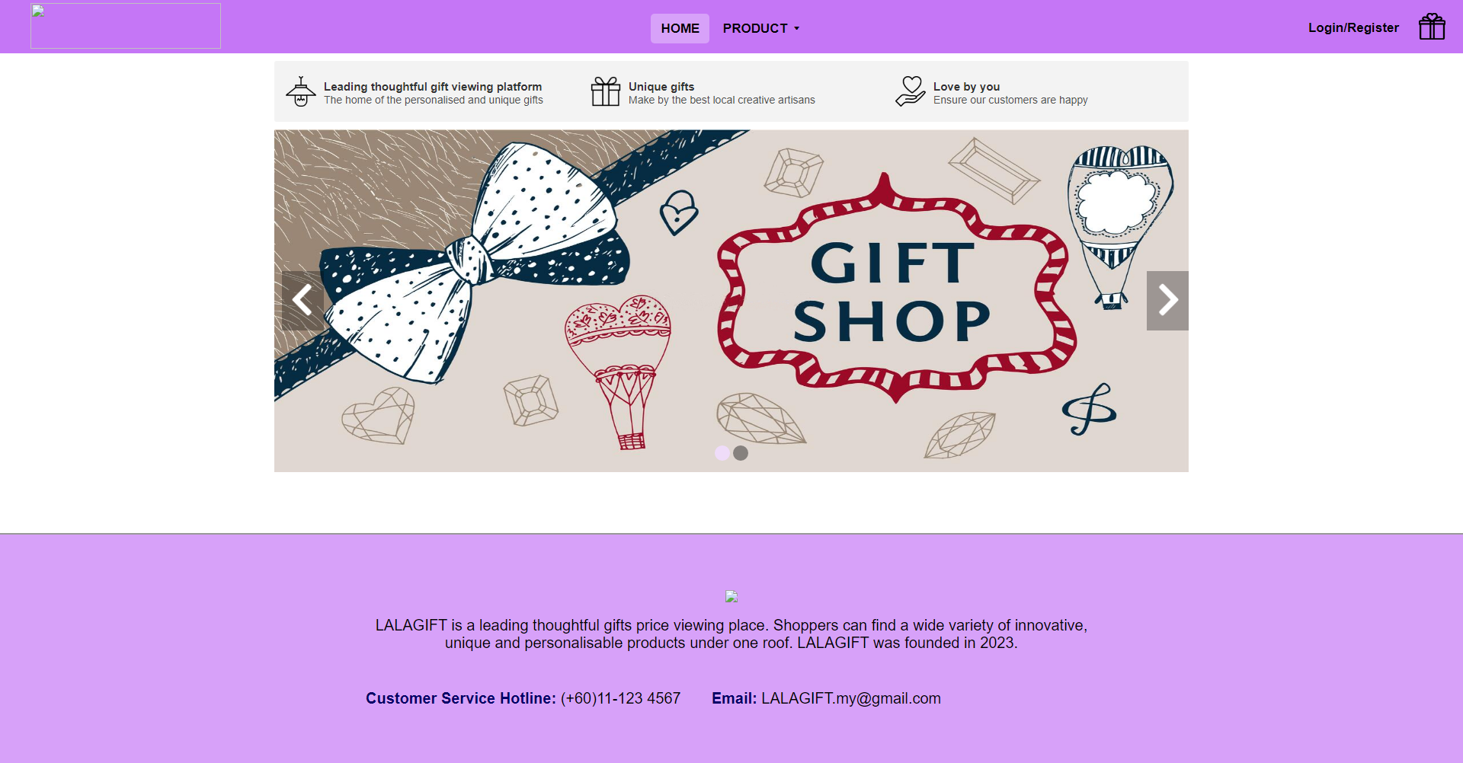

Figure 2 Home page

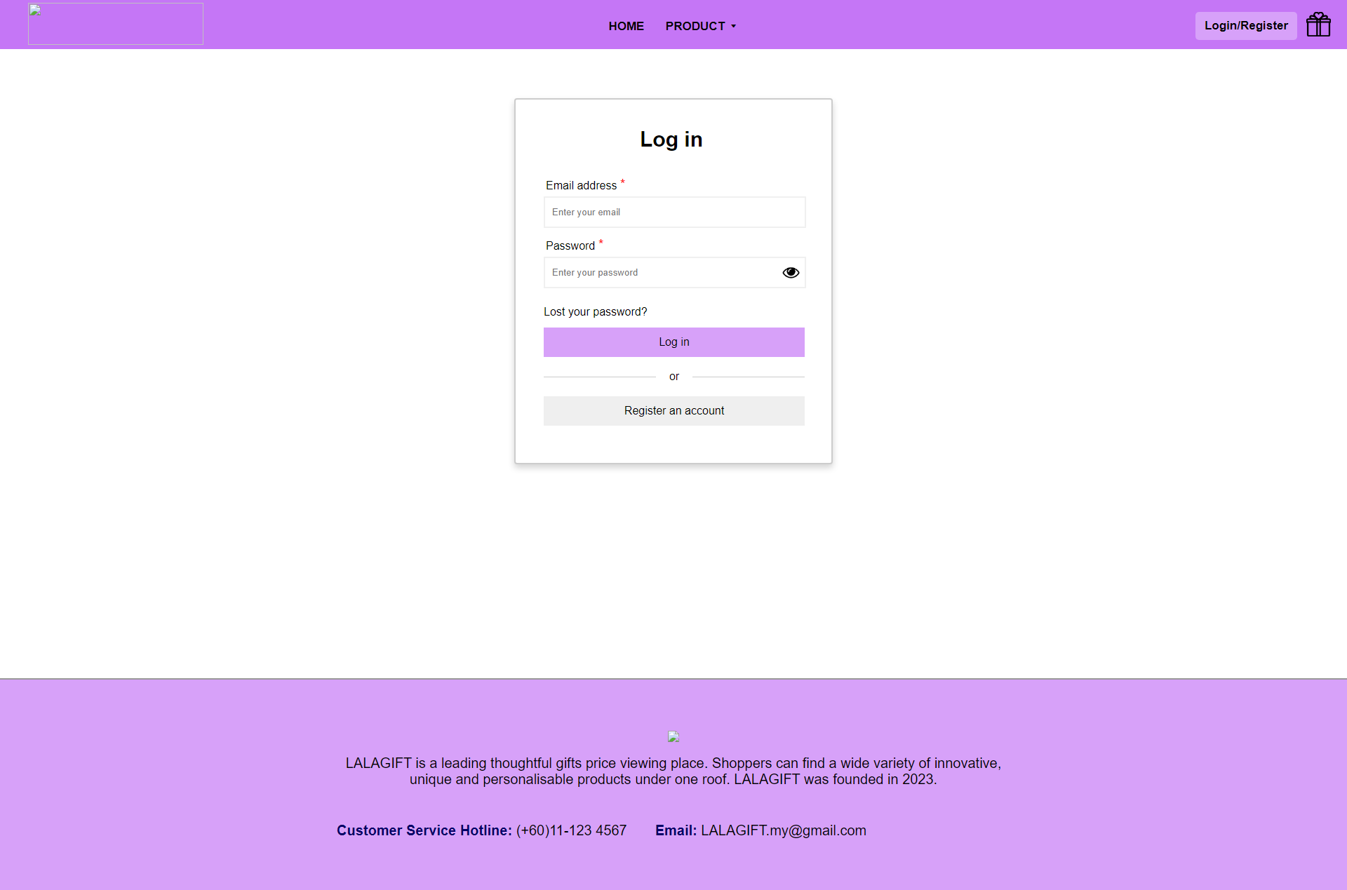

Figure 3 Login page

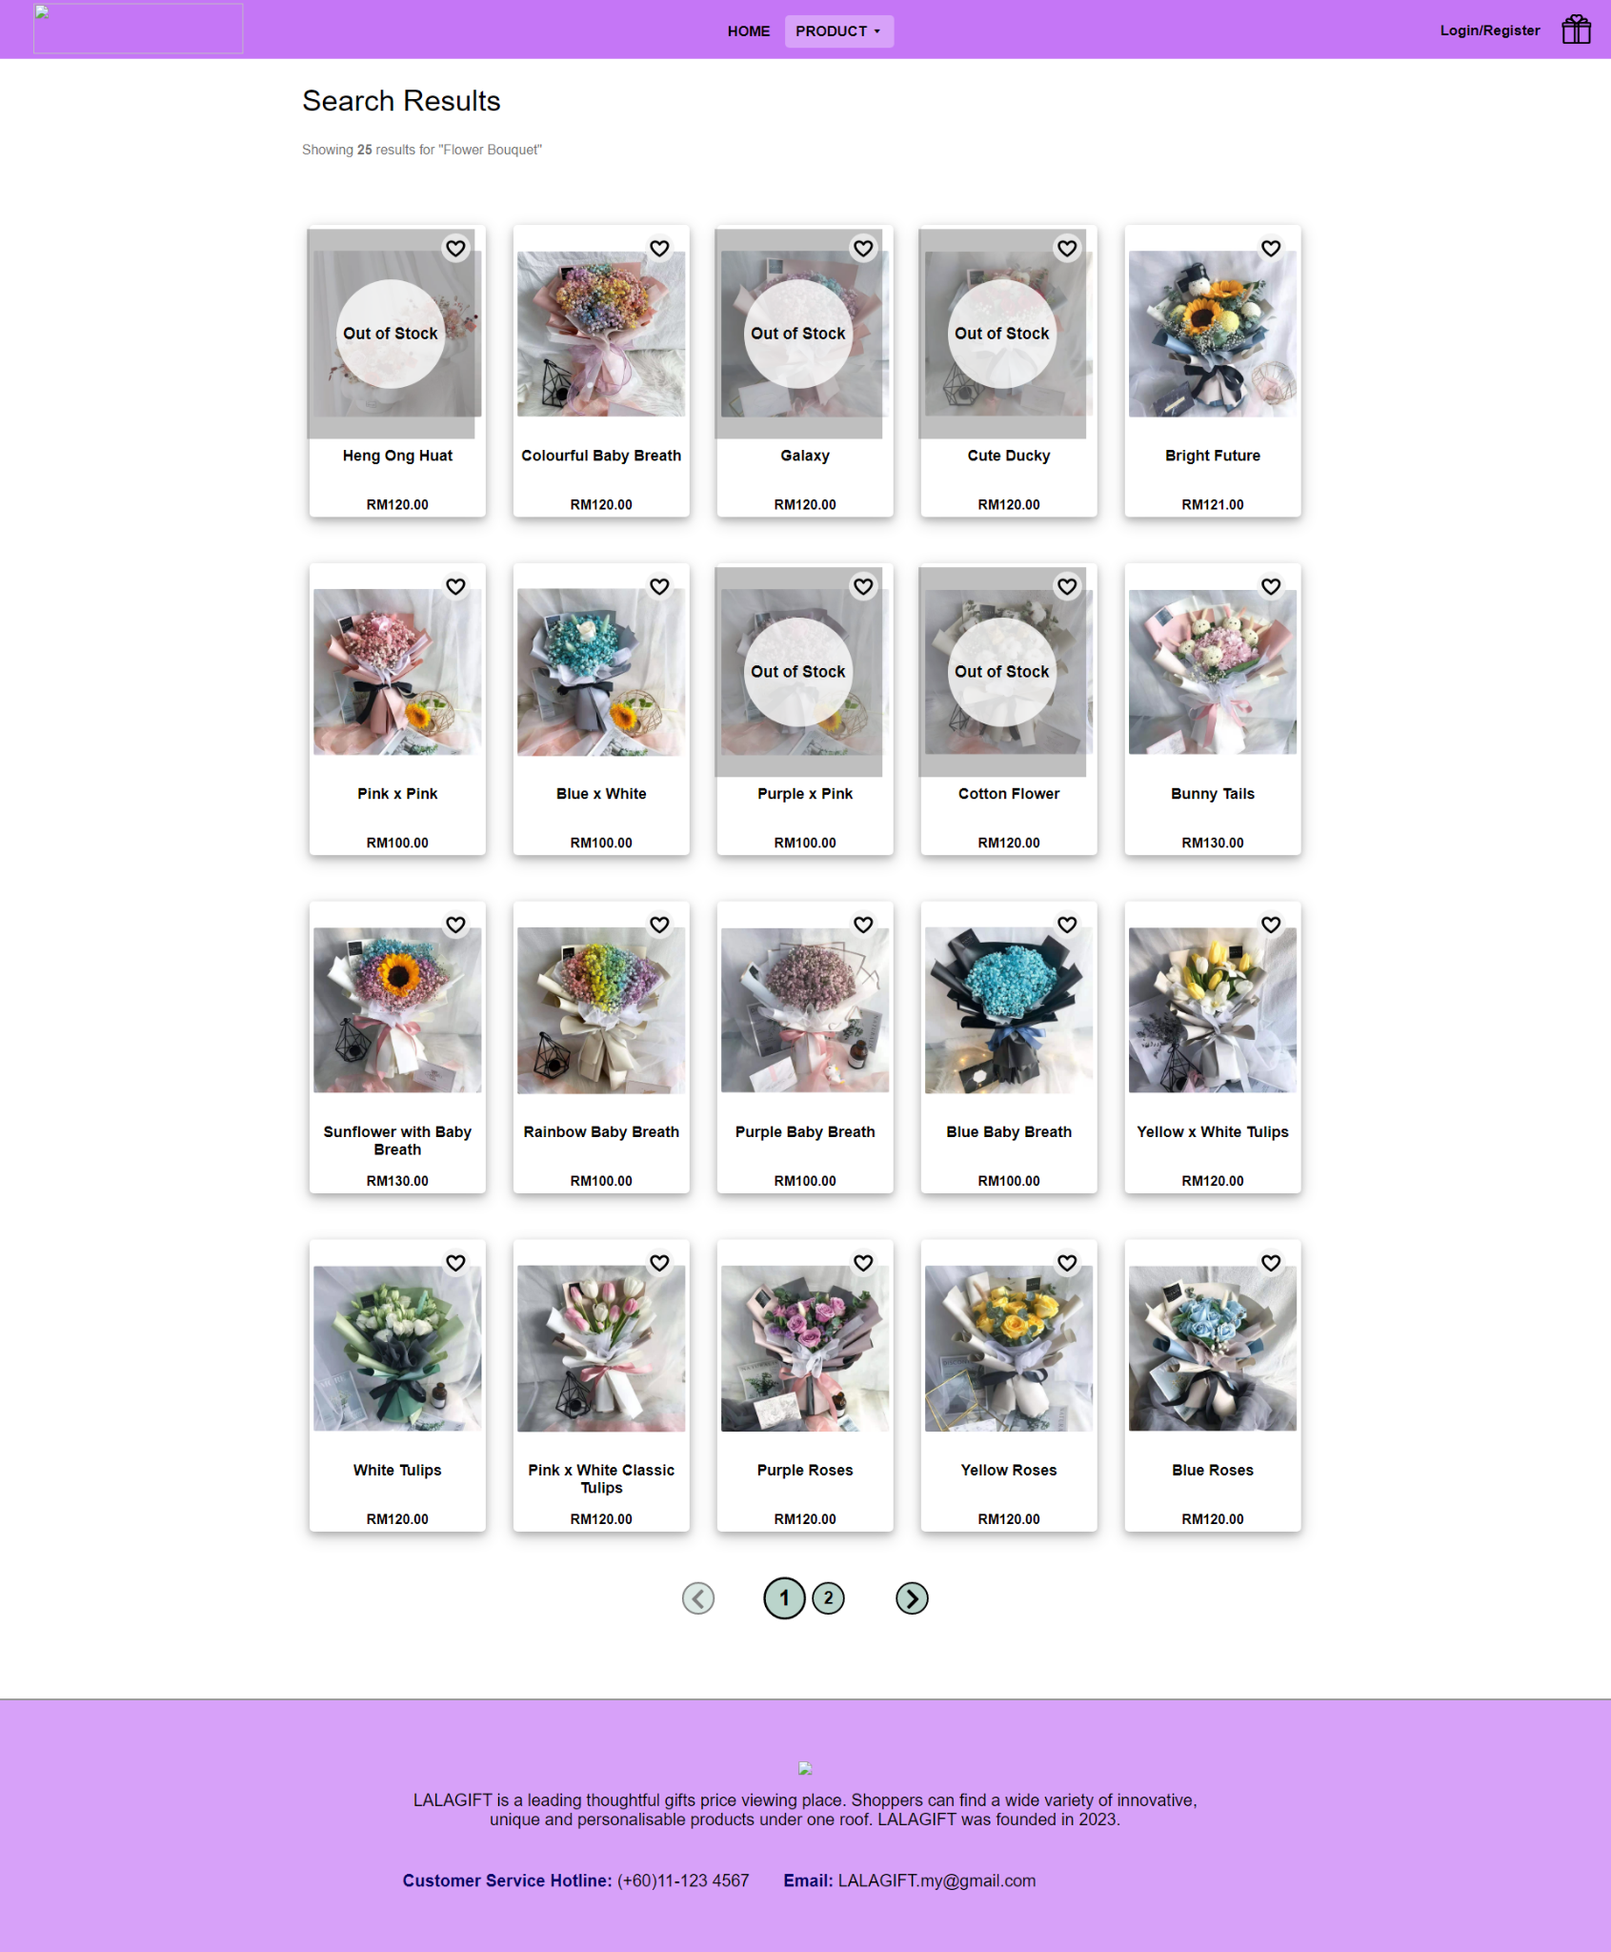

Figure 4 Products page

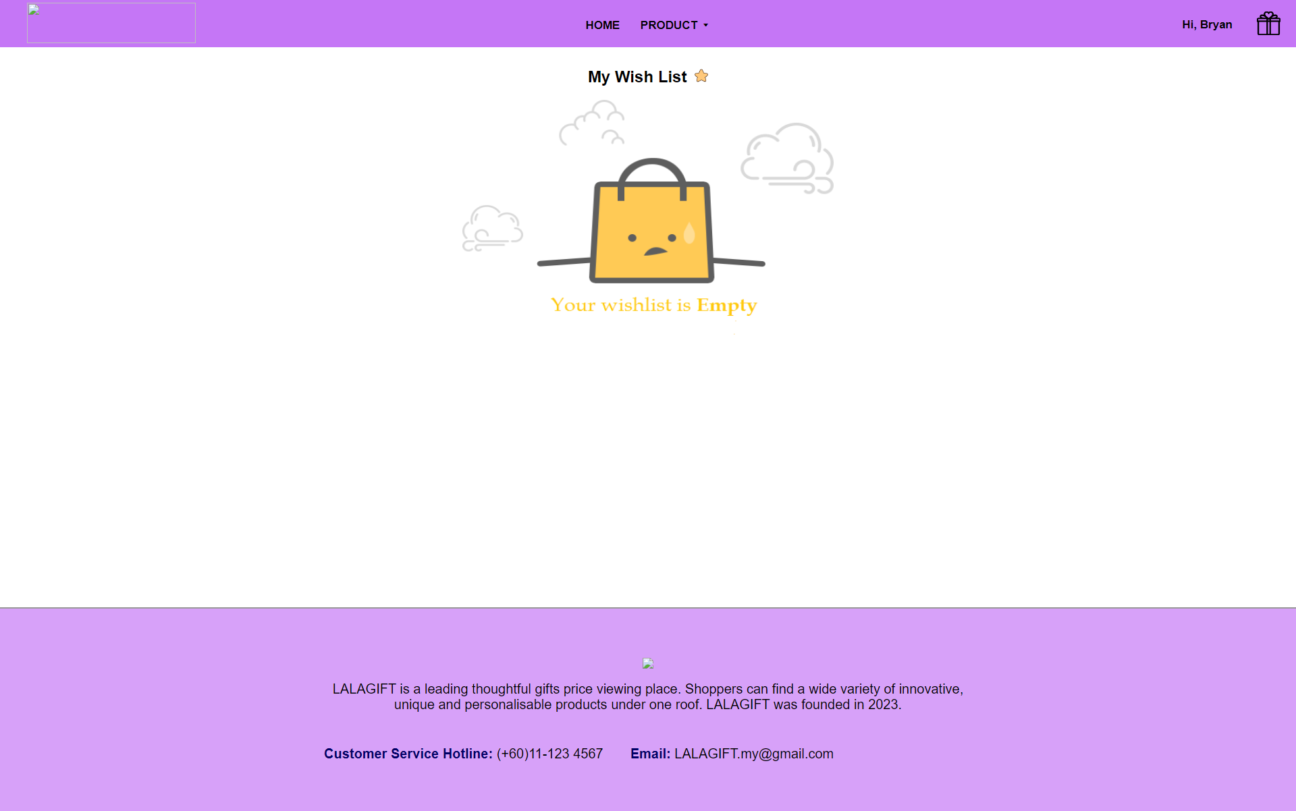

Figure 5 Wishlist without products page

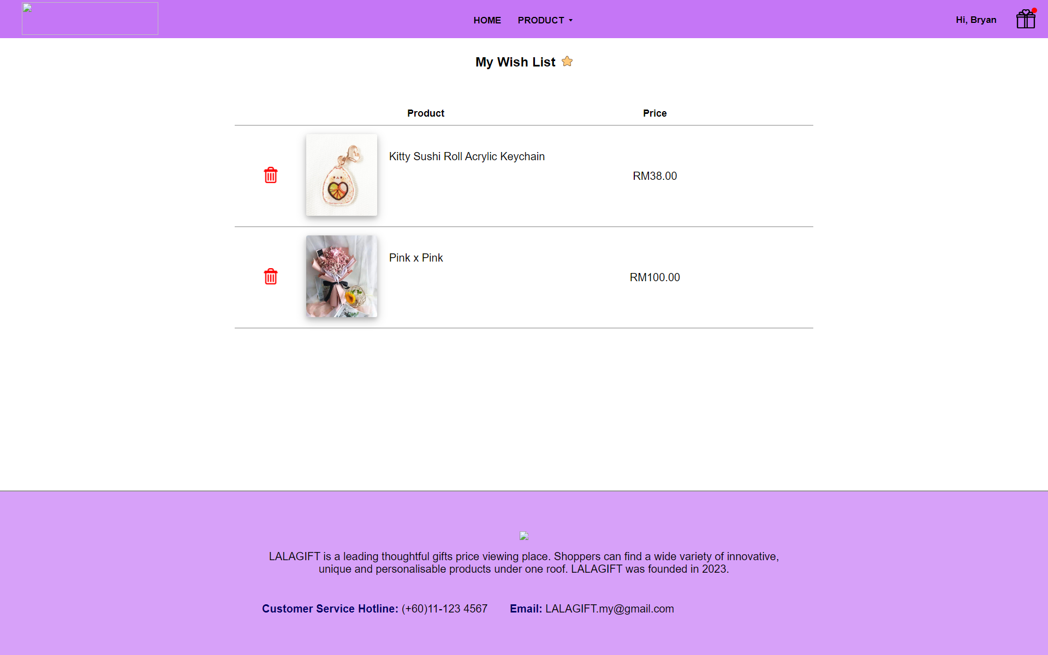

Figure 6 Wishlist with products page

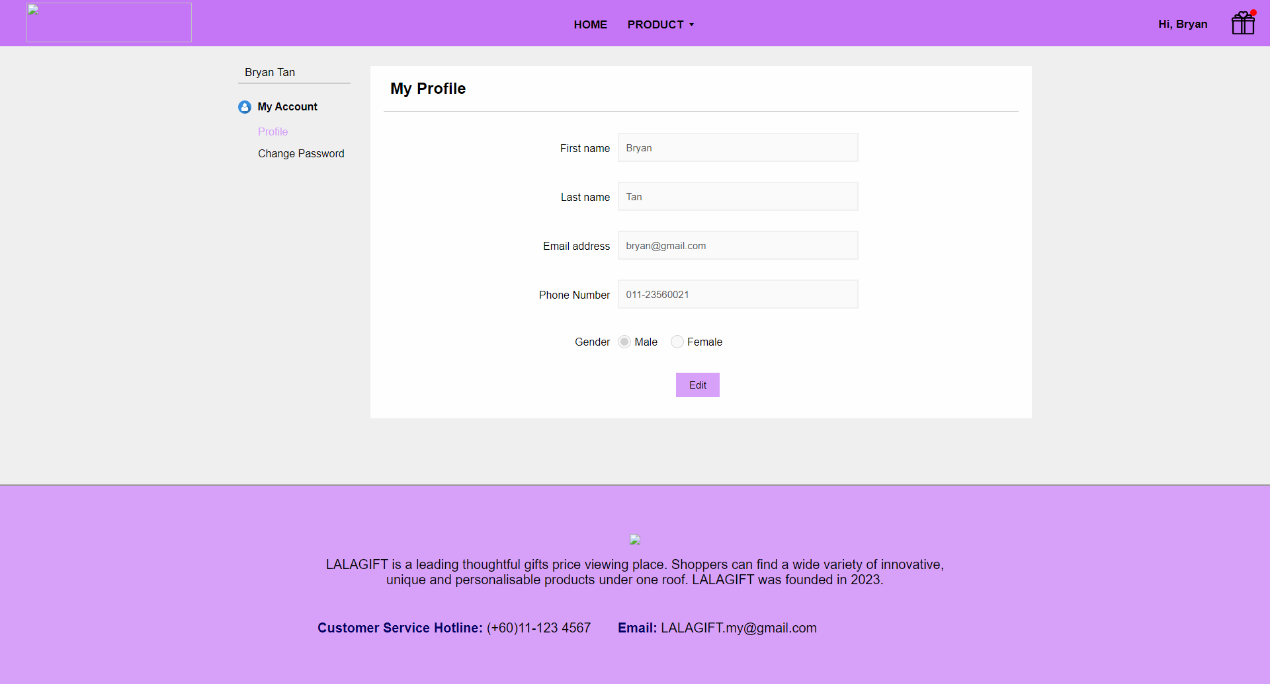

Figure 7 Edit profile page

In this phase, we use Putty as the connection tools to a remote server using SSH or hostname IP. Putty is known as a free and open-source terminal emulator application which allows users to connect a server with SSH or the hostname IP. Before we have the Host IP and also the keypair, we need to launch an instance so that we are able to know the IP address and also to download the key pairs.

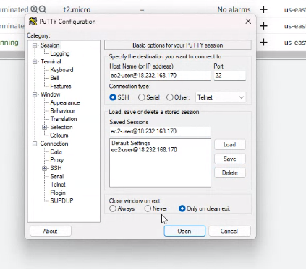

Figure 8 Putty IP

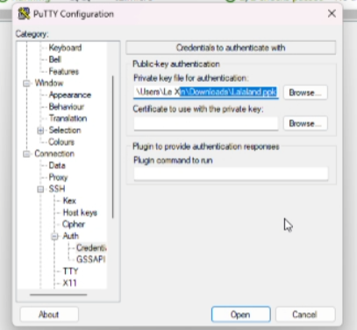

Figure 9 Putty Keypair

**VPC**

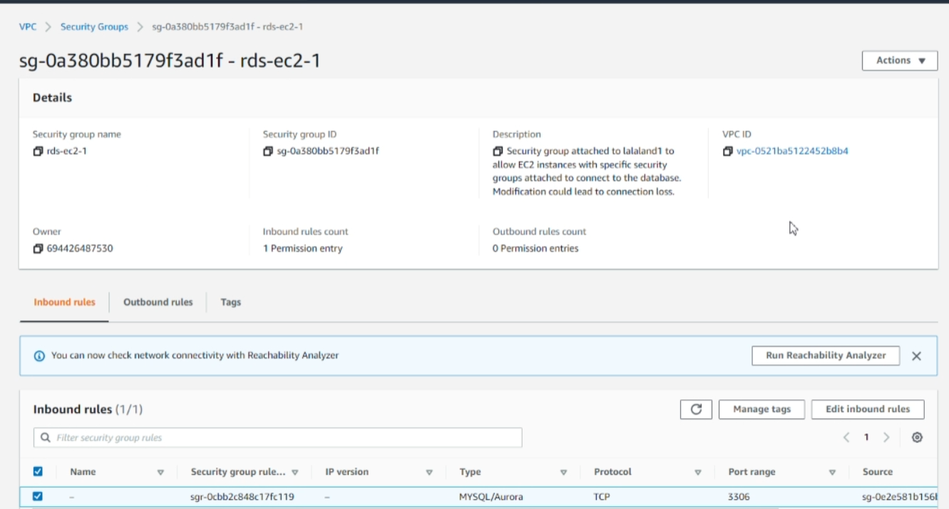

Figure 10

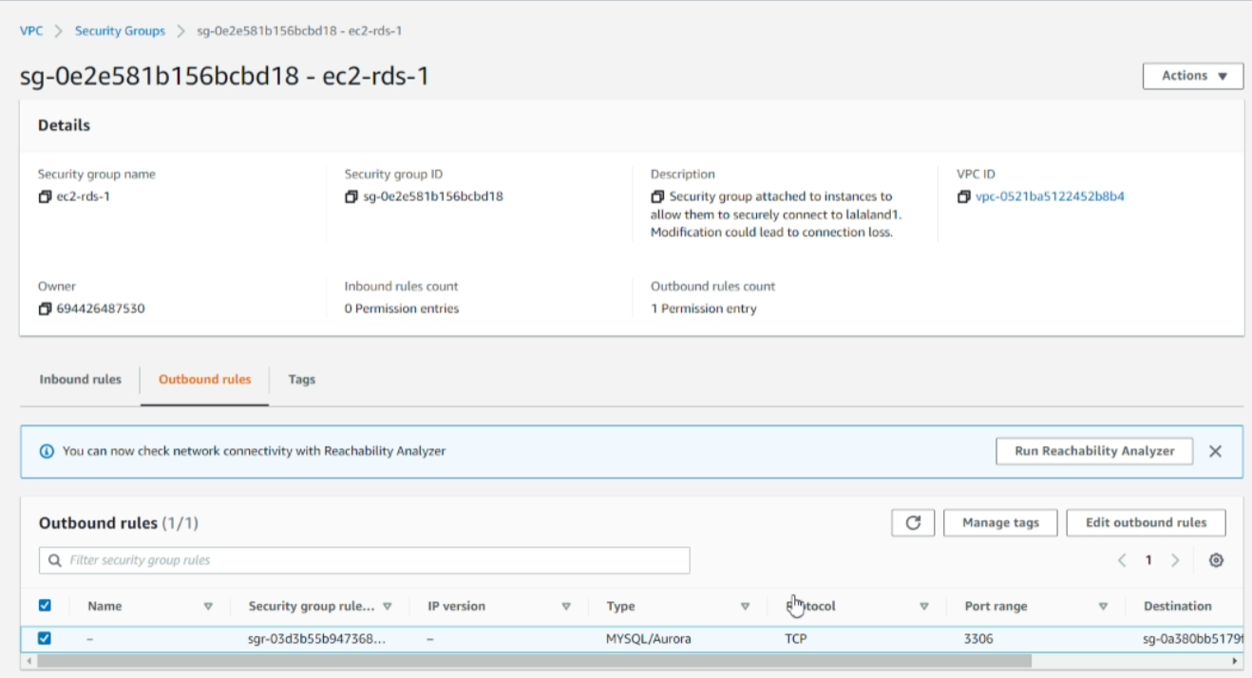

Figure 11

Above figure shows the VPC of our AWS instances, where this is the security groups for the RDS EC2, and it acts as a virtual firewall for our EC2 instances. It controls the inbound and outbound traffic to and from the instances. Figure 10 shows the inbound rules and Figure 11 shows the outbound rules for our instance.

**Gateway**

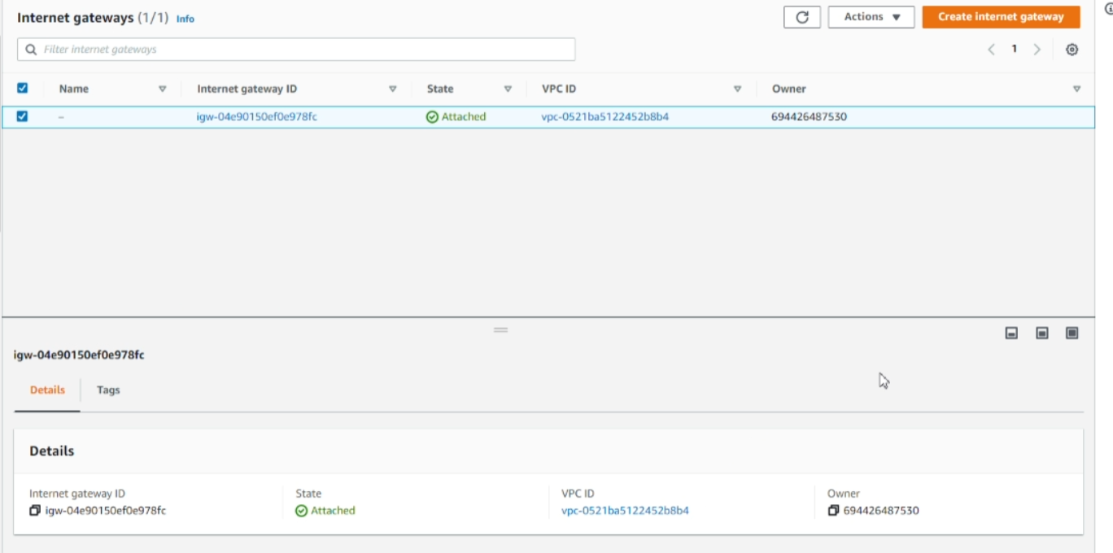

Figure 12

Gateway refers to a service that allows communication between different network segments or between on-premises networks and the cloud. In this section, we remain the default setting.

**Subnet**

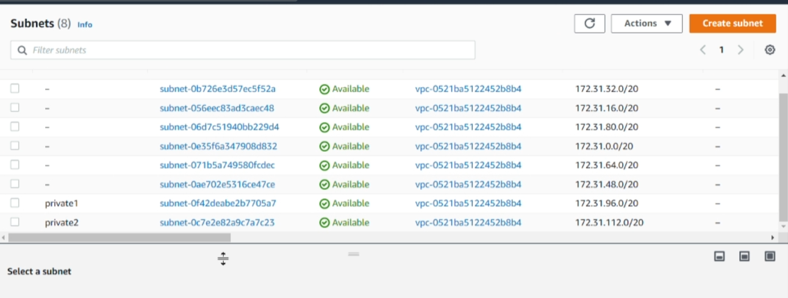

Figure 13

Subnet is the range of IP addresses in a VPC that can be used to launch EC2 instances and we created a few public subnets and also 2 private subnets.

**EC2**

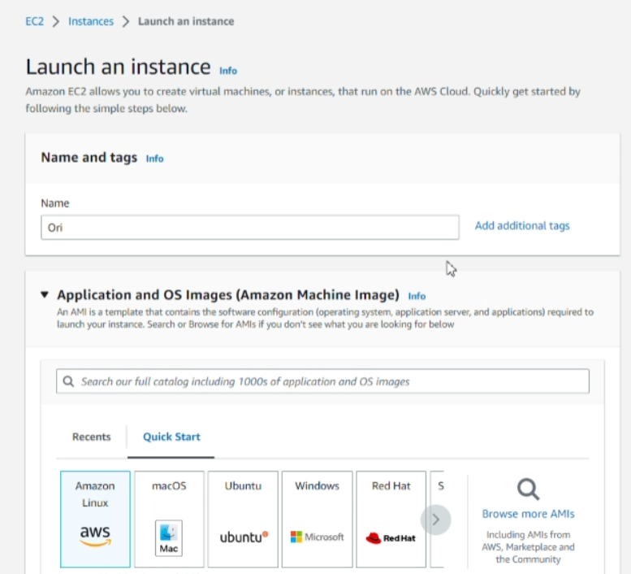

Figure 14

While creating the EC2, we set the name as ‘Ori’ and selected amazon linux as the OS.

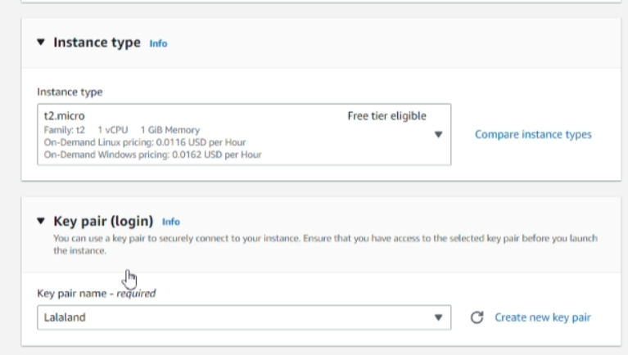

Figure 15

Therefore, select the t2.micro as the instance type where it was a good choice for certain types of workloads, where it is designed for low moderate usage and also it is great for small to medium-sized workloads such as small web servers, which we are going to do in this project.

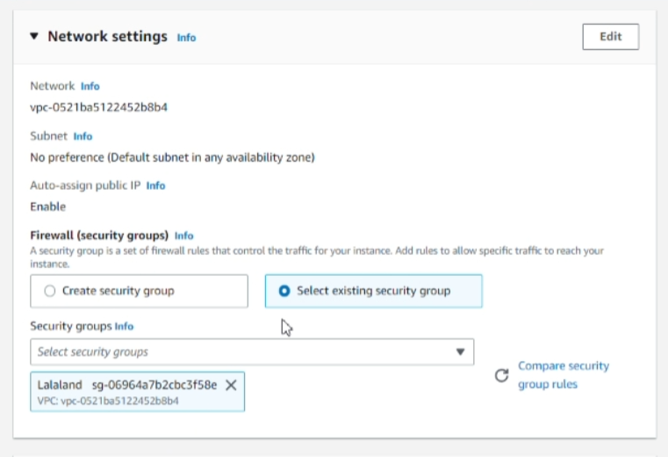

Figure 16

In networks settings, we change the security group to a predefined security groups named ‘Lalaland’

**Accessible IP**

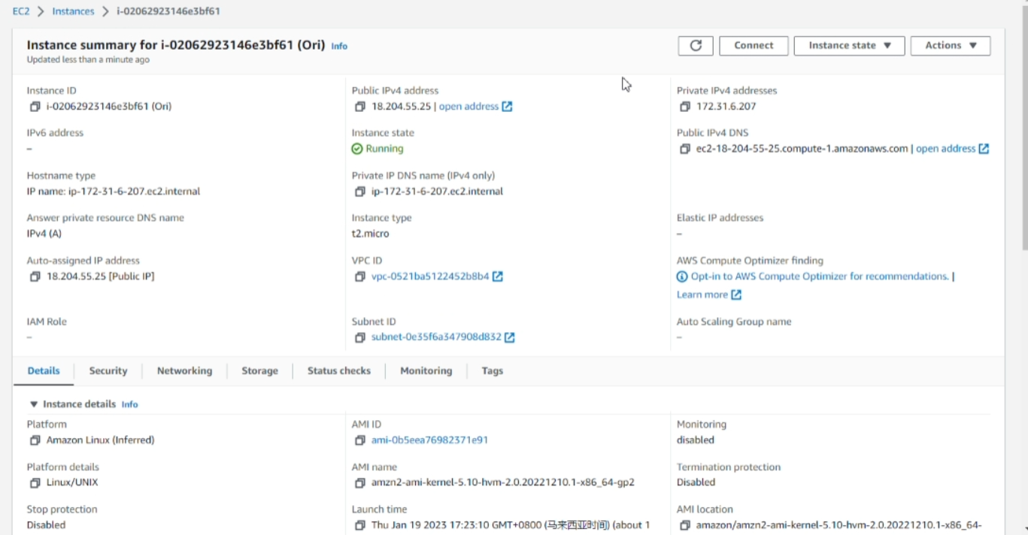

Figure 17

The accessible IP for our website are as shown in the above figure, 18.204.55.25. You are able to access our website using this IPv4 address with HTTP.

## **Phase 2**

**A new private subnet**

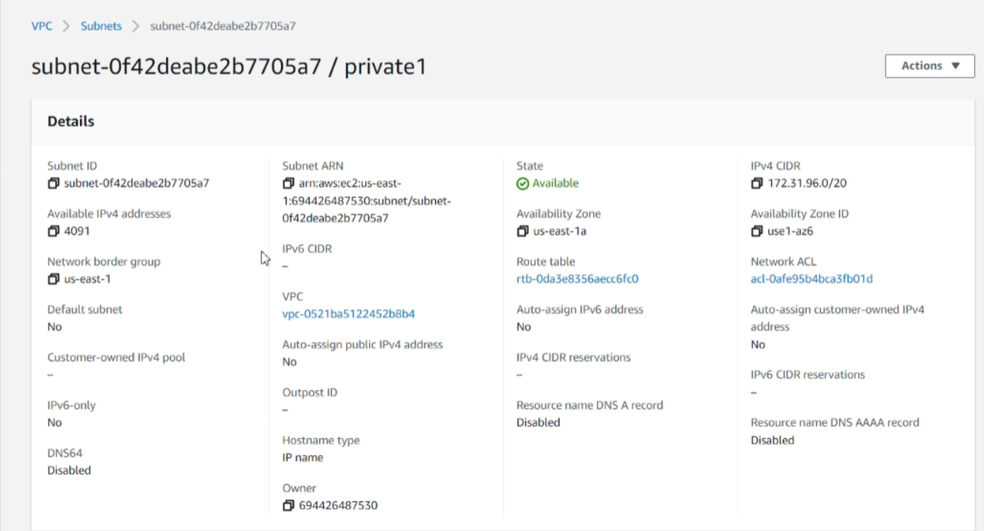

Figure 18

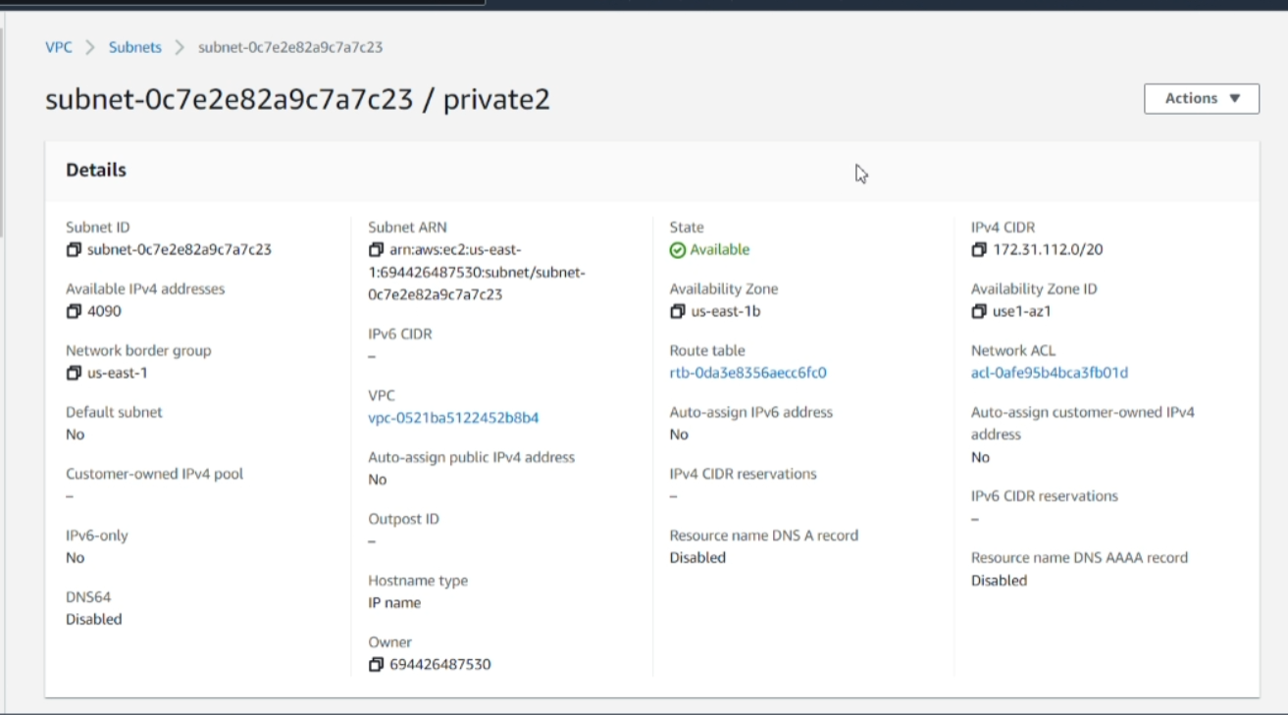

Figure 19

Above are the private subnets of our VPC where the availability zones for them are us-east-1a and us-east-1b.

**A new RDS MySQL instance**

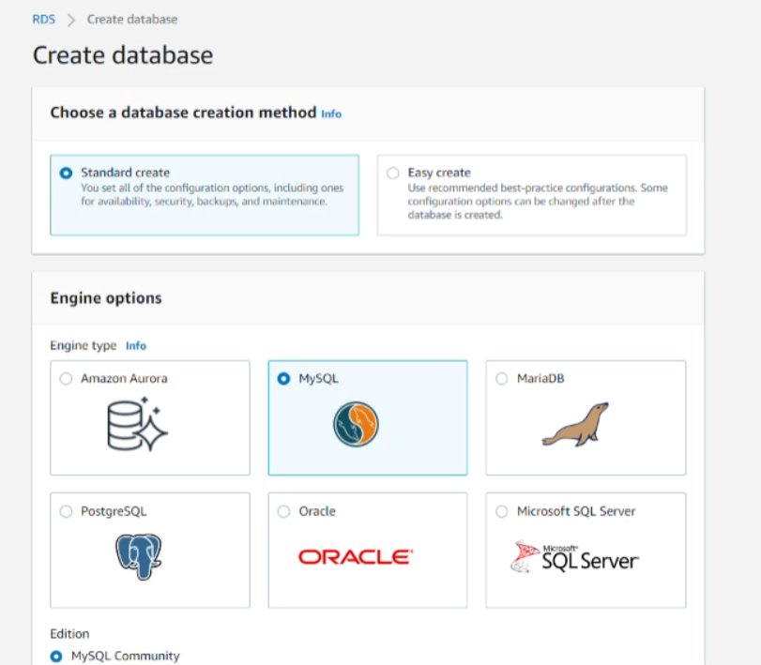

Figure 20

While creating the RDS MySQL instances, select standard create as the method and also MySQL as the engine option.

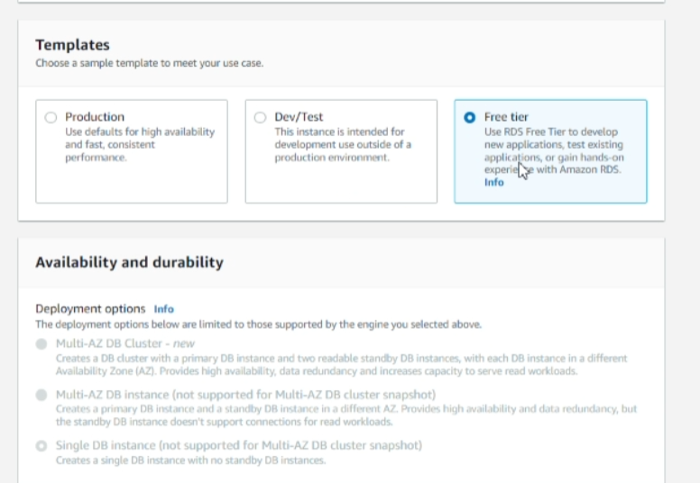

Figure 21

Therefore, the template we use is the free tier.

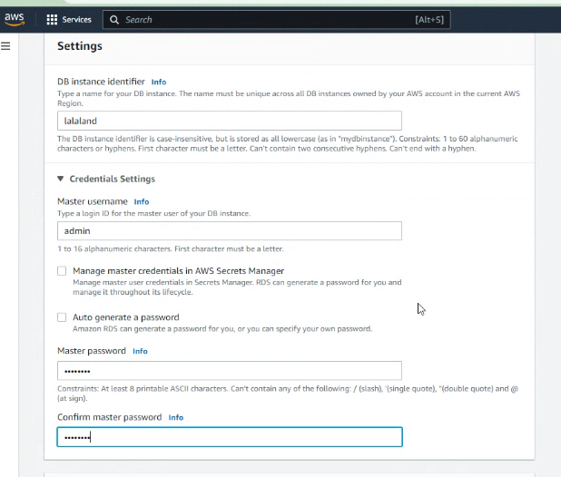

Figure 22

Setup for the DB identifier, which is ‘lalaland’ and the credentials settings are admin with a master password.

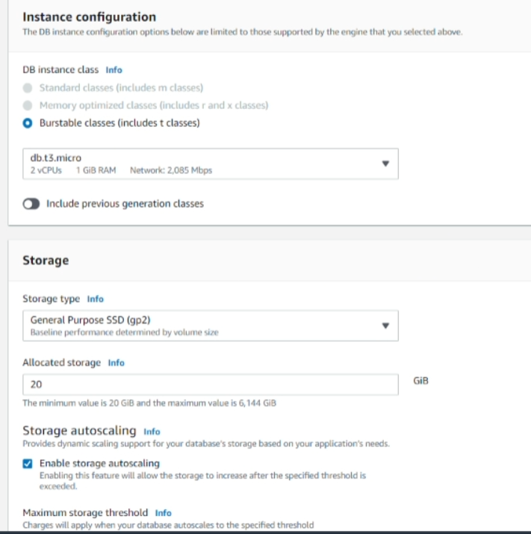

Figure 23

The option was to remain as default where the instance configuration option was ticked on the burstable classes option and select db.t3.micro.

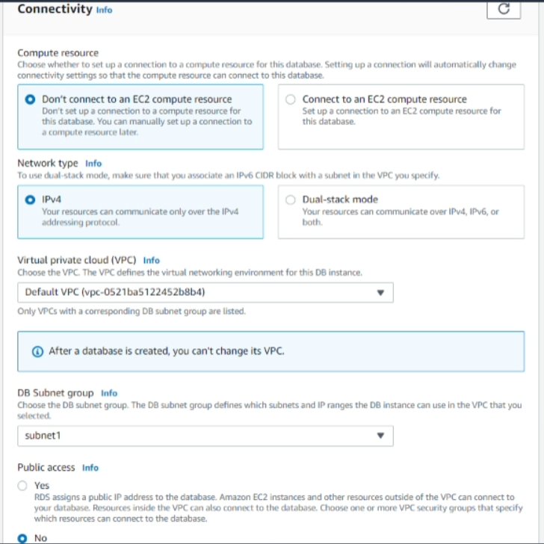

Figure 24

In the connectivity part, the compute resource was chosen as don’t connect to an EC2 compute resource and IPv4 was selected in network type. The VPC we choose is default VPC and Subnet group for database is subnet1.

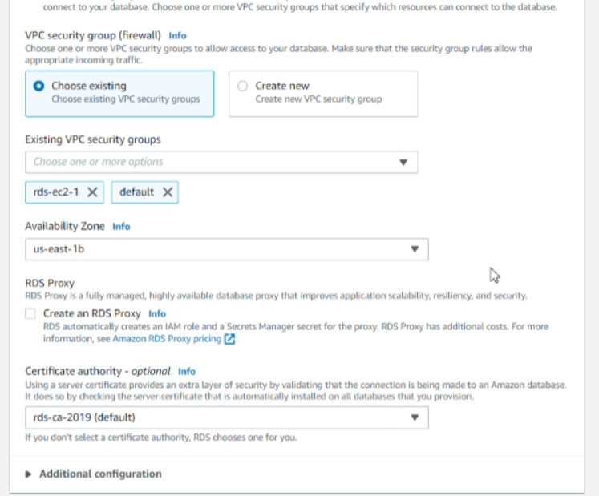

Figure 25

For VPC security group, we choose the existing one where one is the default and one more is the rules that we have created, rds-ec2-1 and set the availability zone as us-east-1b

**Dump local MySQL**

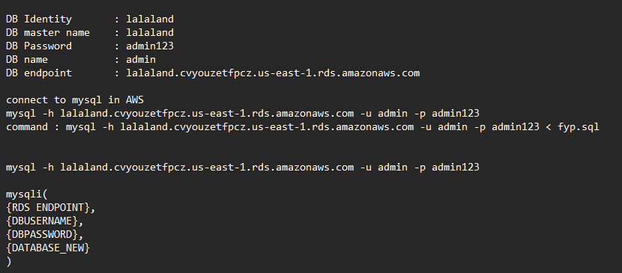

Figure 26

This is the database information which needs to be used in php to connect to the database. The command was type in puTTy to upload the sql file to our database.

## **Phase 3**

**A new public subnet**

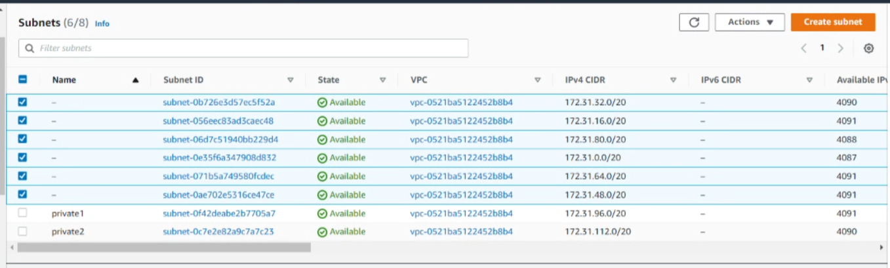

Figure 27

All the ticked subnet is the public subnet, and we use the default subnets for all of them.

**Multi-AZ capability**

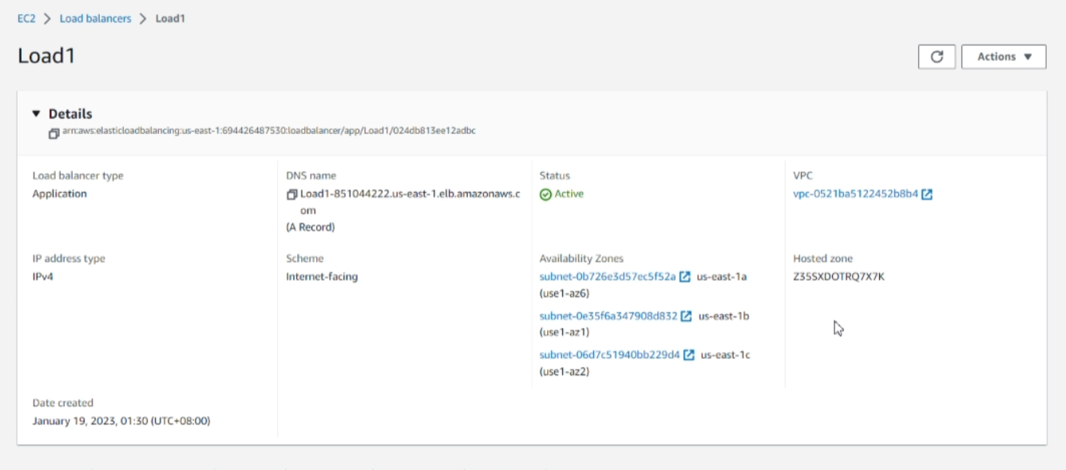

Figure 28

There are 6 availability zones, which is us-east-1a until es-east-1f.

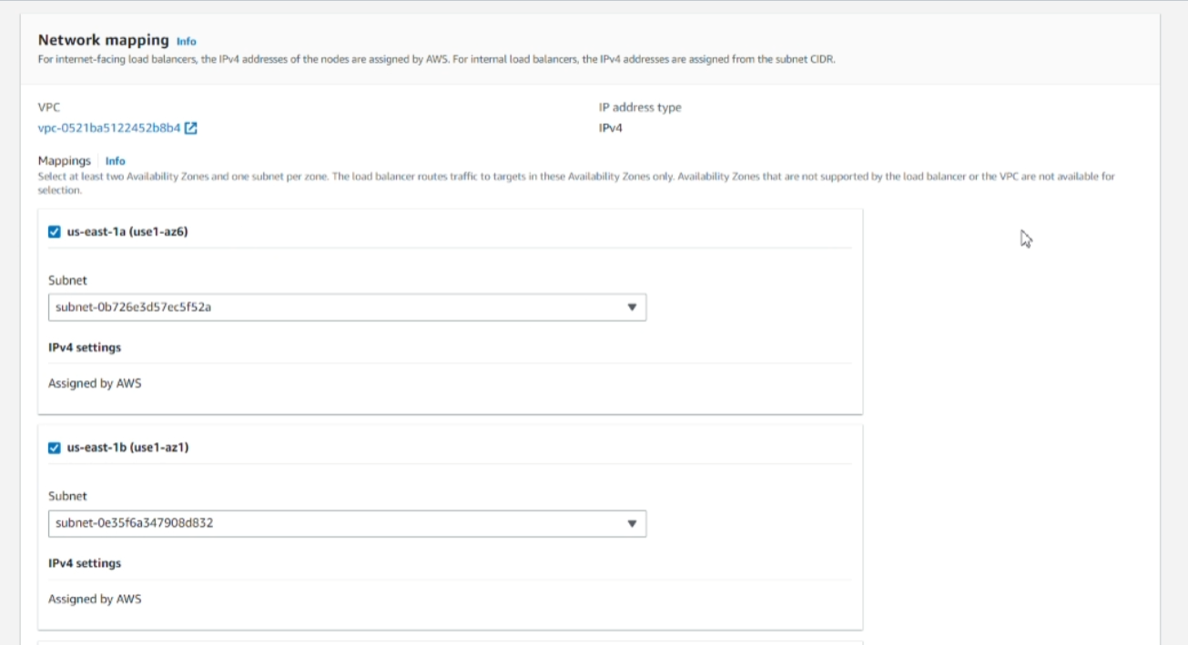

Figure 29

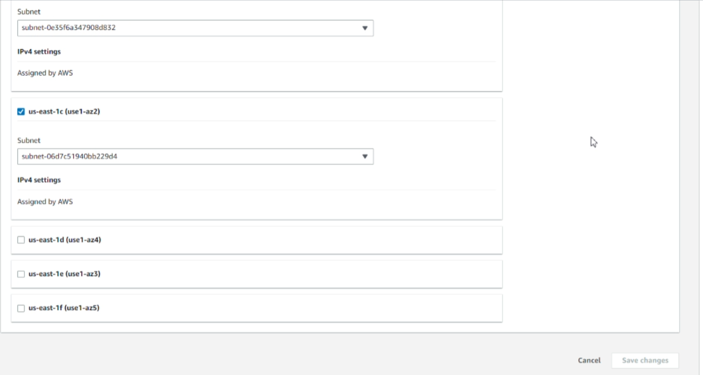

Figure 30

We only use us-east-1a, us-east-1b, and us-east-1c as the availability zones capability.

**Accessible ELB DNS**

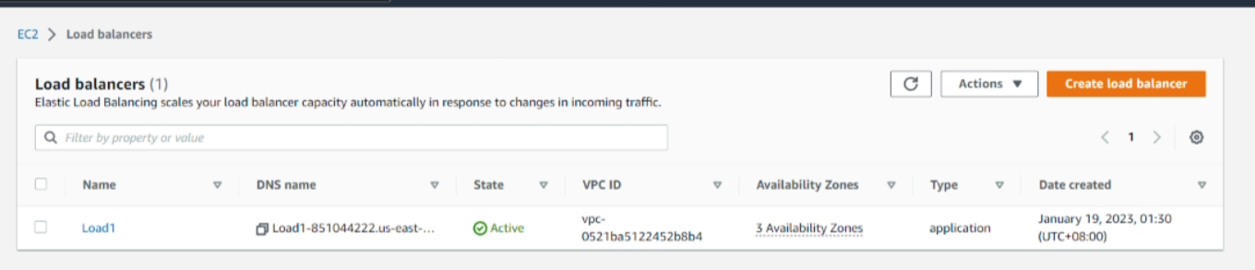

Figure 31

By using the ELB DNS link, which is under the DNS name in the above figure.We are able to access the website using(shown in below)

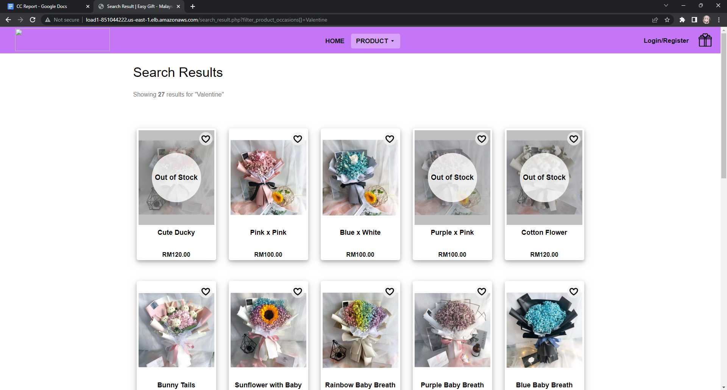

Figure 32

## **Phase 4**

**Auto Scaling properties:**

**EC2**

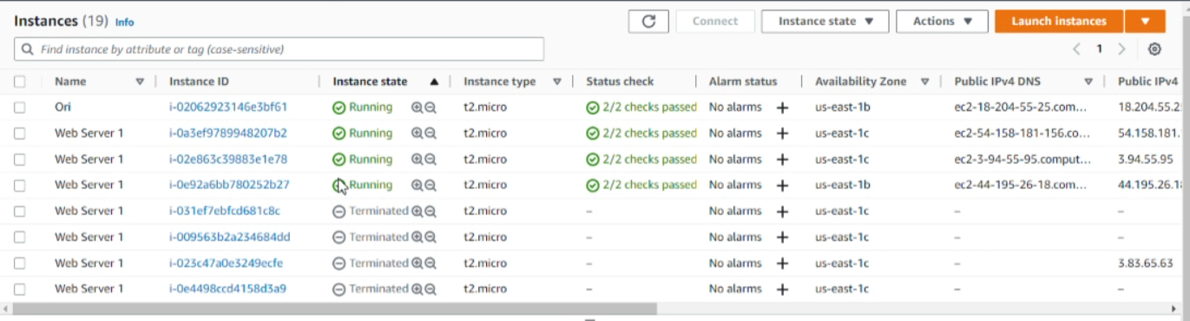

Figure 33

Above shows all the instances of our EC2, where the Ori is the default instance that we use.

**Number of instances**

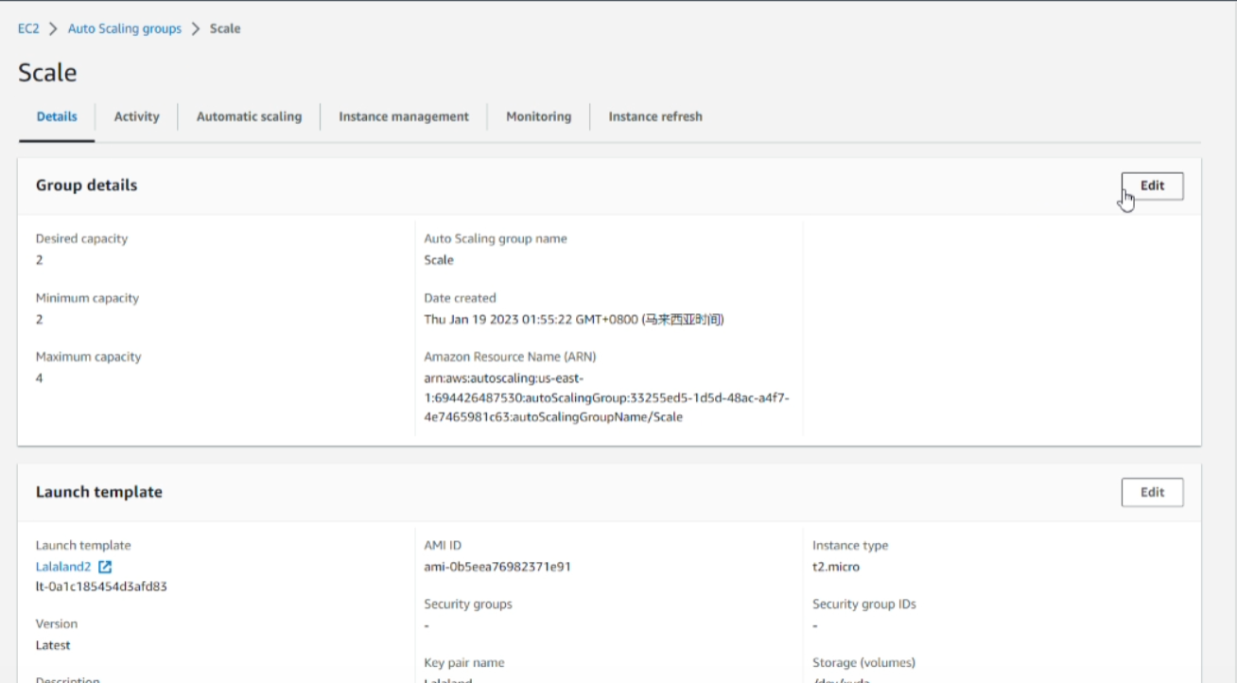

Figure 34

We also set some rules for the instances where the desired capacity and minimum capacity is 2 and maximum capacity is 4 instances as a total.

**Scaling policies**

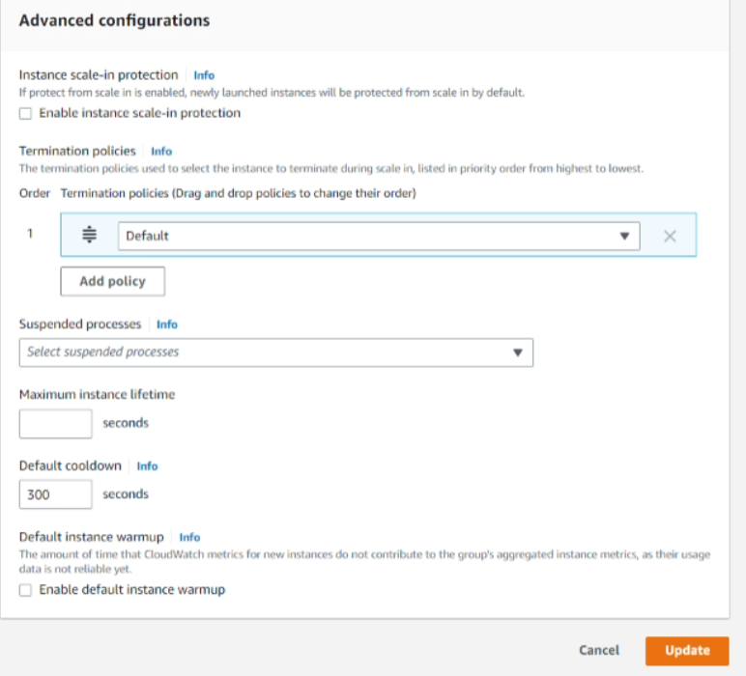

Figure 35

Last, the scaling policies, we set the default cooldown as 300 seconds, so that in every 5 minutes, the

System will terminate the EC2 instance due to ELB system health check failure and launch a new EC2 instance in a different availability zone that we set before which is 1a and 1b.

# Conclusion

In conclusion, using AWS to create a small web server is a cost-effective and efficient solution for hosting a website. With the use of EC2 instances, we were able to easily spin up a virtual server with the desired specifications. Additionally, the use of Elastic IPs and security groups allowed us to easily manage and secure our server. Overall, using AWS allowed us to quickly and easily create a reliable web server that can handle a small amount of traffic, and can easily be scaled up as needed.